Project Design Phase-II
Technology Stack (Architecture & Stack)

Date | 30-09-2026
Team ID | SWTID-2026-5703
Project Name | AI-Augmented Backend Development AI FitTrack API
Maximum Marks | 4 Marks

Technical Architecture:
The Deliverable shall include the architectural diagram as below and the information as per the table1 & table 2
Technical Architecture - AI FitTrack Backend API
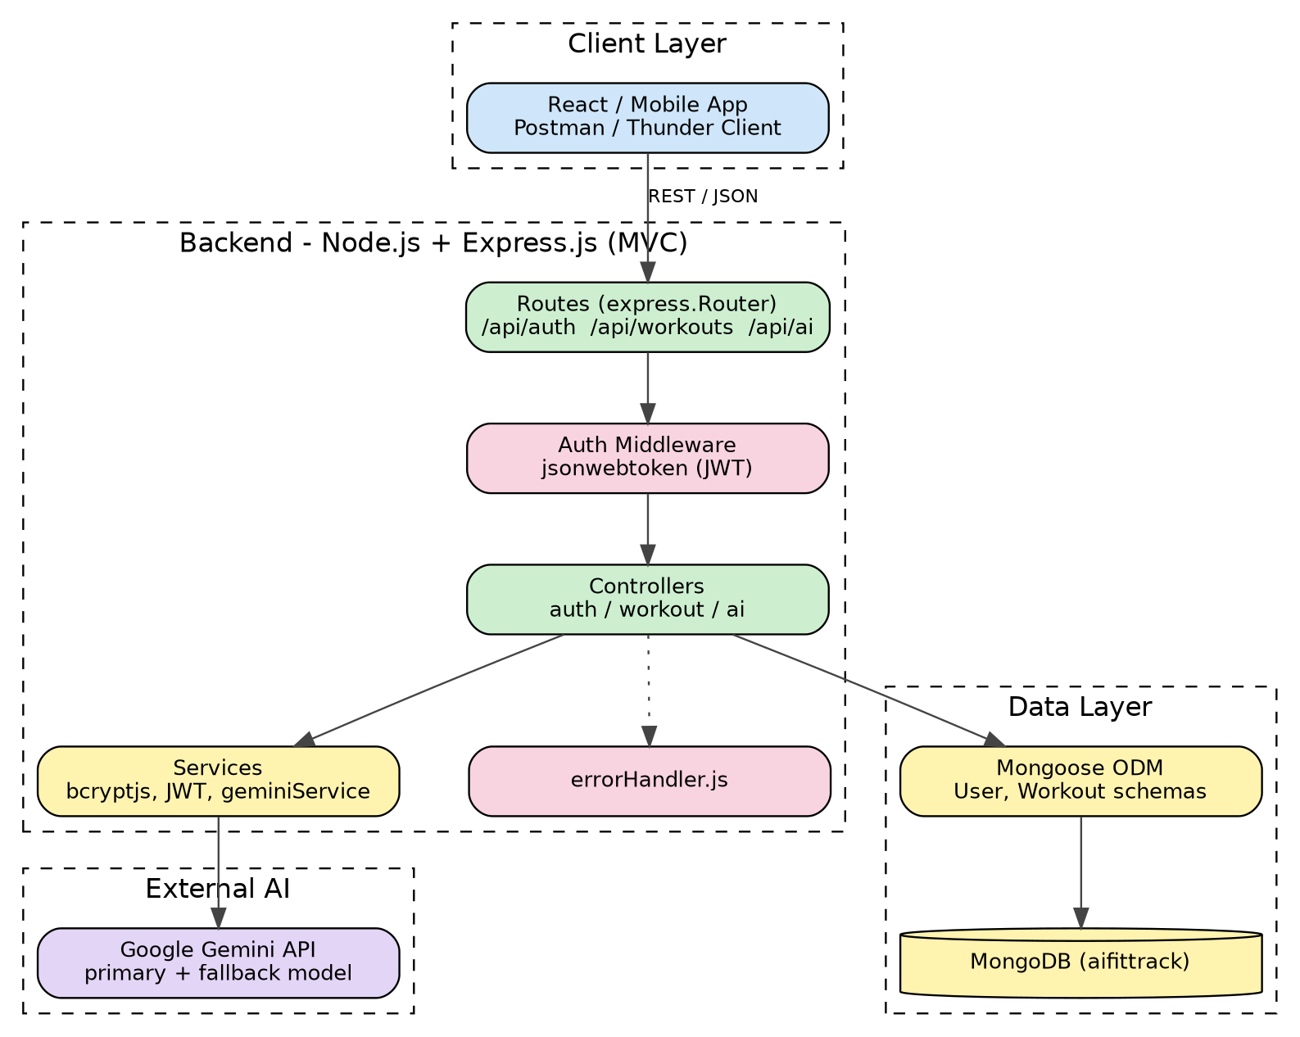

Table-1 : Components & Technologies:
S.No | Component | Description | Technology
 | User Interface | API consumers that call the REST endpoints and store the JWT token: React web app, mobile app, Postman / Thunder Client | React / Mobile App / Postman / Thunder Client
 | Application Logic-1: Authentication | User registration, login, profile retrieval, JWT creation and verification, password hashing | Node.js, Express.js, jsonwebtoken, bcryptjs
 | Application Logic-2: Workout Management | Add, view, search, get by ID, update and delete workouts linked to the authenticated user | Express.js controllers and routes, Mongoose
 | Application Logic-3: AI Service Layer | Builds prompts, calls Gemini for recommendations and insights, retries and falls back to a secondary model | Node.js service (geminiService.js)
 | Database | Users and Workouts collections with schema validation (mongodb://localhost:27017/aifittrack) | MongoDB, Mongoose
 | Cloud Database | Not used in the current version (local MongoDB); a cloud-hosted MongoDB can replace the connection string | MongoDB (local) - cloud option: MongoDB Atlas
 | File Storage | No file uploads; source code and configuration stored on the local filesystem / GitHub repository | Local Filesystem, GitHub
 | External API-1 | Google Gemini API for AI workout recommendations and fitness insights | Google Gemini API
 | External API-2 | Not applicable - no second external API is used | N/A
 | Machine Learning Model | Generative AI model producing personalised plans and insights; primary model with automatic fallback to a lighter model | Google Gemini (gemini-3.8-flash, fallback gemini-3.5-flash-lite)
 | Infrastructure (Server / Cloud) | Local development server running on port 5000; Node.js v16+, npm v8+, MongoDB; Windows 10/11, macOS or Linux; 8 GB RAM recommended 16 GB, Intel i5 8th Gen / Ryzen 5 | Local (Node.js + MongoDB), VS Code

Table-2: Application Characteristics:
S.No | Characteristics | Description | Technology
 | Open-source frameworks | Backend framework, ODM and supporting libraries are open source | Express.js, Mongoose, dotenv, cors, nodemon, bcryptjs, jsonwebtoken
 | Security implementations | JWT-protected routes, bcrypt password hashing (salt rounds 10), secrets in .env, schema validation, CORS | JWT, bcrypt.js, auth middleware, dotenv
 | Scalable architecture | Layered MVC with separate routes, controllers, services and models; stateless authentication supports horizontal scaling | Node.js, Express.js, MongoDB
 | Availability | Retry and automatic fallback to a secondary Gemini model keep AI features available during high demand (503 errors) | Gemini retry + model fallback
 | Performance | Non-blocking asynchronous Node.js, unique index on email, lightweight JSON responses | Node.js async/await, MongoDB, Mongoose

References:
Express.js - Routing guide: https://expressjs.com/en/guide/routing
Mongoose - Schema validation: https://mongoosejs.com/docs/validation.html
JSON Web Token - Introduction (jwt.io): https://jwt.io/introduction
bcryptjs - password hashing for Node.js (npm): https://npmjs.com/package/bcryptjs
Google Gemini API - Text generation (official docs): https://ai.google.dev/gemini-api/docs/text-generation
Postman - Quick start for sending and testing API requests: https://learning.postman.com/docs/getting-started/quick-start
AI FitTrack API - project source code (GitHub): https://github.com/ksuriyamsdgk-max/Ai-Augmented-Backend-Development-AI-FitTrack-API

